HACETTEPE UNIVERSITY
Department of Computer Engineering

Fuzzy Modelling
Laboratory

Furkan Simsekli
5th Semester
Turkey

Academic Year 2023/2024

Exercise 2

Write a script to draw a symmetrical trapezoidal membership function and Gaussian membership functions, which are described by the following mathematical relations:

DS = 0.25 R = [-15,15]

C1 – magenta C2 – cyan C3 – red

Draw the membership functions µ_{A}(x), µ_{B}(x) and µ_{C}(x) on one graph in the range of R. Use a DS discretization step and the following colors µ_{A}(x) – C1, µ_{B}(x) – C2 and µ_{C}(x) – C3.

Write the equations describing the support, the core and the α-cut of a fuzzy set. Determine the support and core of the fuzzy sets: support (A), core(A), core(B) and core(C).

Determine the α-cut of the fuzzy sets: α-cut(A) for α=0.2 and α-cut(B) for α=0.5.

Solution

% Trapezoidal membership function and Gaussian membership functions
x1=[-15:0.25:0]
y1=0*x1
x2=[0:0.25:3]
y2=1/3*x2
x3=[3:0.25:5]
y3=0*x3+1
x4=[5:0.25:8]
y4=-1/3*x4+2.6667
x5=[8:0.25:15]
y5=0*x5

xa=[x1 x2 x3 x4 x5]
ya=[y1 y2 y3 y4 y5]

xb=[-15:0.25:15]
yb=exp(-(((xb-5)/2).^2))

xc=[-15:0.25:15]
yc=exp(-(((xc+8)/4).^2))

% plot the curves
plot(xa,ya,'m',xb,yb,'c',xc,yc,'r')
grid on

% axis, line width, font size
set(gca,'fontsize',16)

% add descriptions to the drawn graphs
text(0,0.9,'MFA','fontsize',16)
text(6,0.9,'MFB','fontsize',16)
text(-6,0.9,'MFC','fontsize',16)

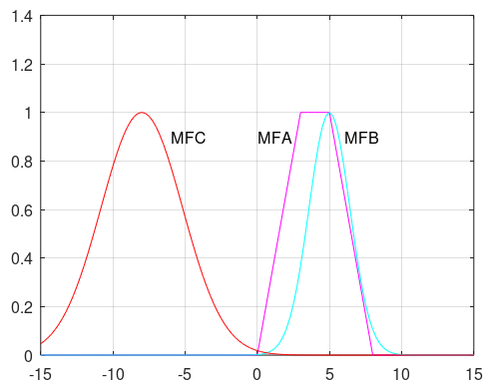
Figure 2.1: The trapezoidal membership functions MFA, and Gaussian membership functions MFB, MFC

support(A) = {0.25, 0.5, 0.75, 1, 1.25, 1.5, 1.75, 2, 2.25, 2.5, 2.75, 3, 3, 3.25, 3.5, 3.75, 4, 4.25, 4.5, 4.75, 5, 5, 5.25, 5.5, 5.75, 6, 6.25, 6.5, 6.75, 7, 7.25, 7.5, 7.75}

core(A) = [3, 5]
core(B) = {5}
core(C) = {-8}

α-cut(A) for α=0.2
α-cut(A) = {0.25, 0.5, 0.75, 1, 1.25, 1.5, 1.75, 2, 2.25, 2.5, 2.75, 3, 3, 3.25, 3.5, 3.75, 4, 4.25, 4.5, 4.75, 5, 5, 5.25, 5.5, 5.75, 6, 6.25, 6.5, 6.75, 7, 7.25}

α-cut(B) for α=0.5
α-cut(B) = {3.5, 3.75, 4, 4.25, 4.5, 4.75, 5, 5, 5.25, 5.5, 5.75, 6, 6.25, 6.5}

% Trapezoidal membership function and Gaussian membership functions
x1=[-15:0.25:0]
y1=0*x1
x2=[0:0.25:3]
y2=1/3*x2
x3=[3:0.25:5]
y3=0*x3+1
x4=[5:0.25:8]
y4=-1/3*x4+2.6667
x5=[8:0.25:15]
y5=0*x5

xa=[x1 x2 x3 x4 x5]
ya=[y1 y2 y3 y4 y5]

xb=[-15:0.25:15]
yb=exp(-(((xb-5)/2).^2))

xc=[-15:0.25:15]
yc=exp(-(((xc+8)/4).^2))
l02=xb*0+0.2
l05=xc*0+0.5

% plot the curves
plot(xa,ya,'m-o',xb,yb,'c-o',xc,yc,'r',xb,l02,'m',xc,l05,'c')
grid on

% axis, line width, font size
set(gca,'fontsize',16)

% add descriptions to the drawn graphs
text(0,0.9,'MFA','fontsize',16)
text(6,0.9,'MFB','fontsize',16)
text(-6,0.9,'MFC','fontsize',16)

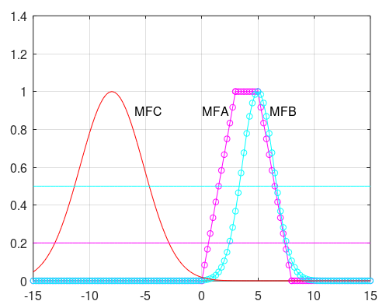

Figure 2.2: The trapezoidal membership functions MFA, and Gaussian membership functions MFB, MFC

